Assignment 3

Name: Soumyadip Ghosh

Stream: CSE Roll Number: 1951007

Section: A

*Comments: Class assignments of 3rd week lab (all 4-debugging assignment) were shown to AS sir and are not pending.*

DB6

Here we assign breakpoints to the following lines:

* for loop
* n1=1/n2
* sum=sum+n1

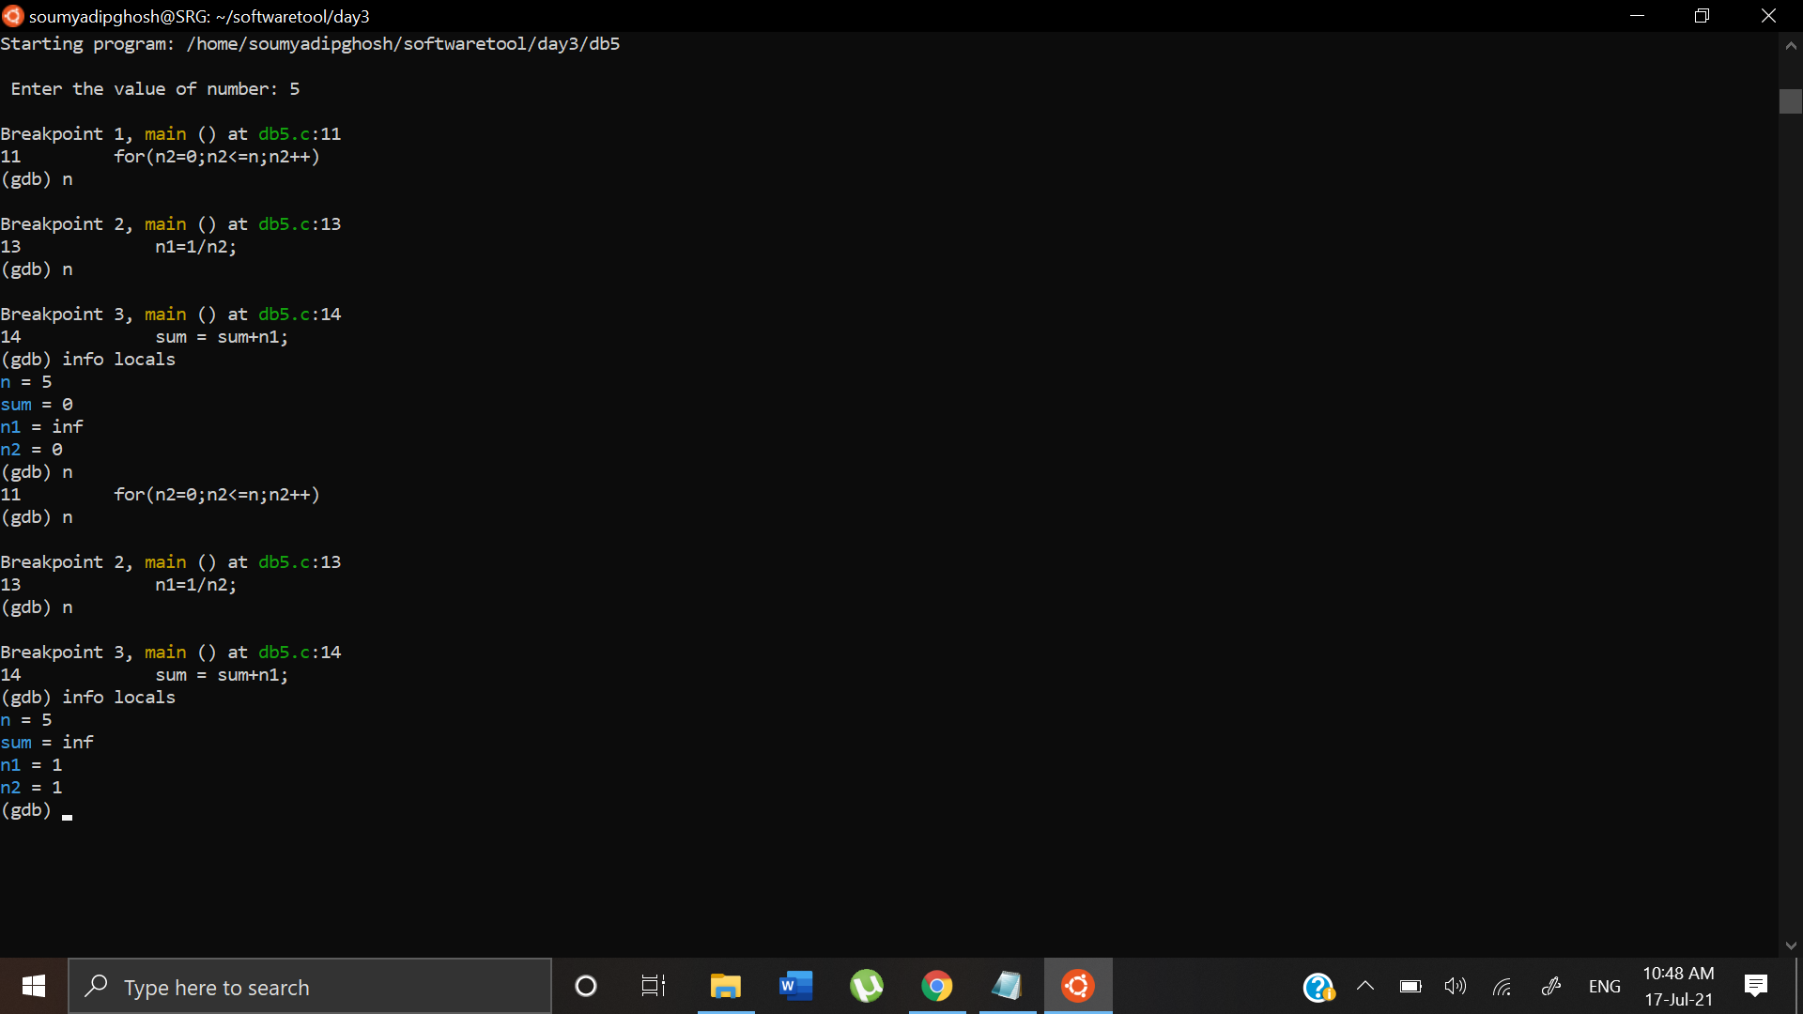

Here after first iteration, we can see that sum=inf. As a result of which after the program is executed, the following output occurs at the end

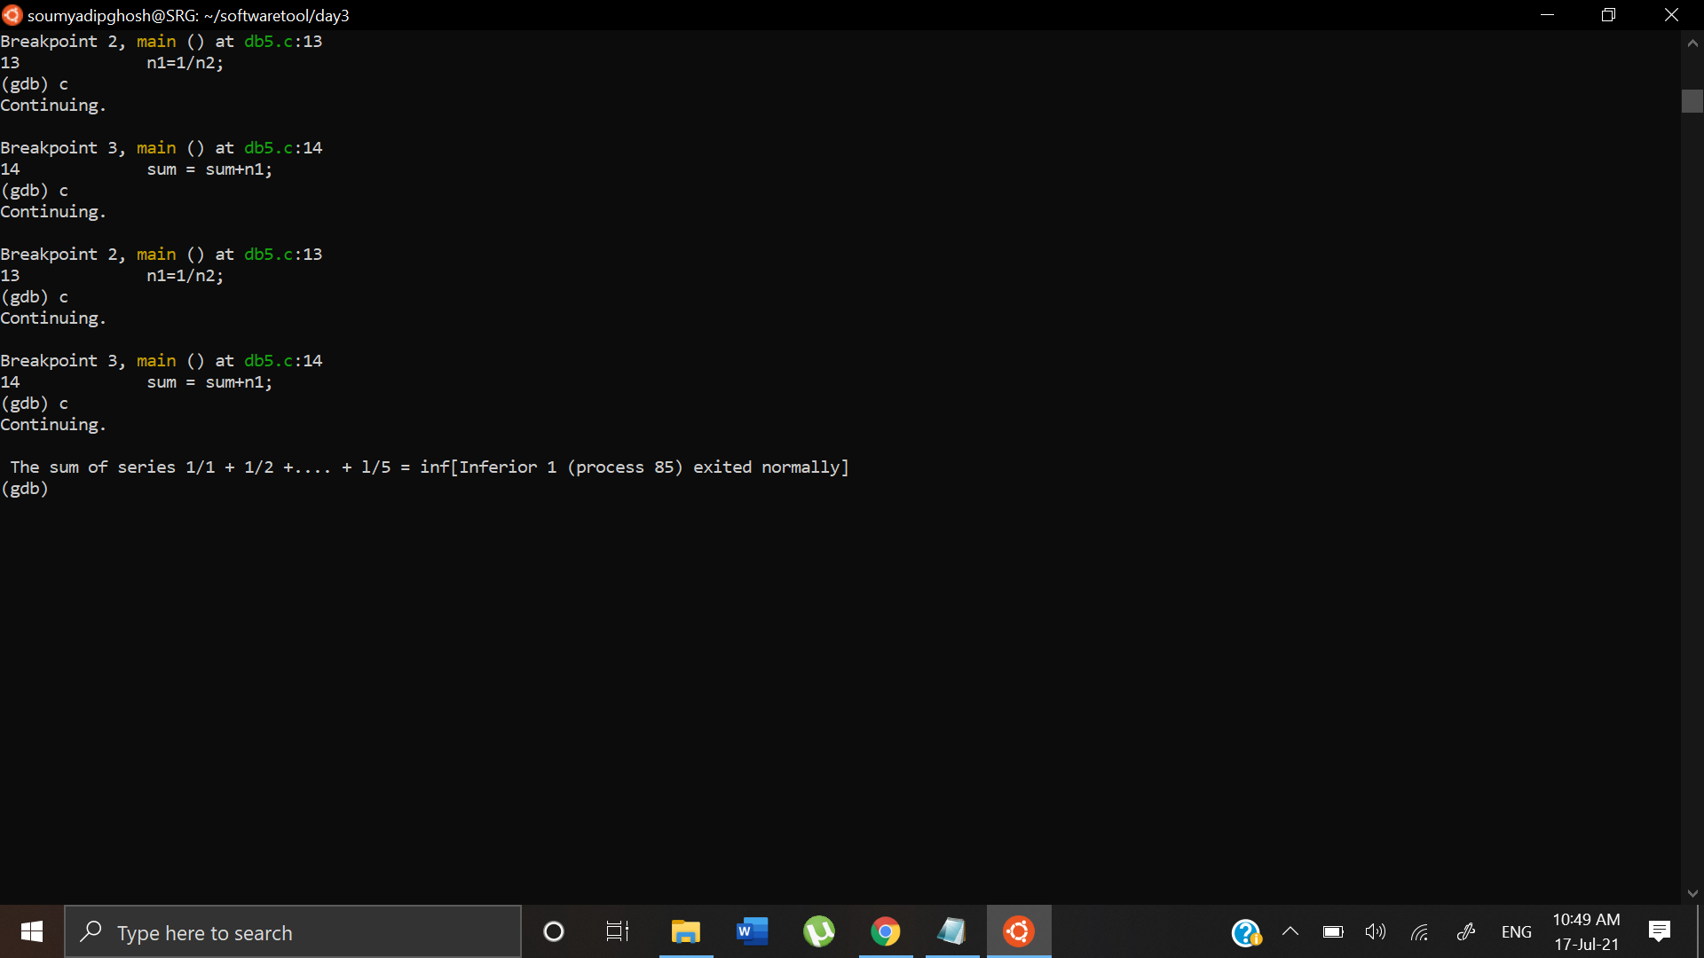

From this we can infer that the sum is coming to be undefined due to the fact that in the first iteration, n2=0. Hence n1 = 1/n2 which will give an inf value. This is a logical error and will work if the loop starts from n2=1.

DB9:

We assign the breakpoints to the following lines:

* gets(buff)
* the if and else statements

Case 1:

We provide the correct password

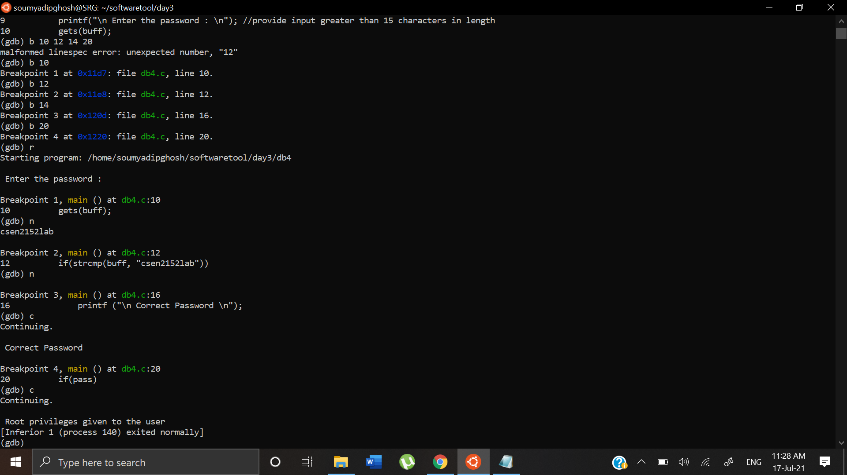

Here we can see that the program is working correctly printing Correct Password and granting root privileges to the user.

Case 2:

We provide an incorrect password less than 15 characters long

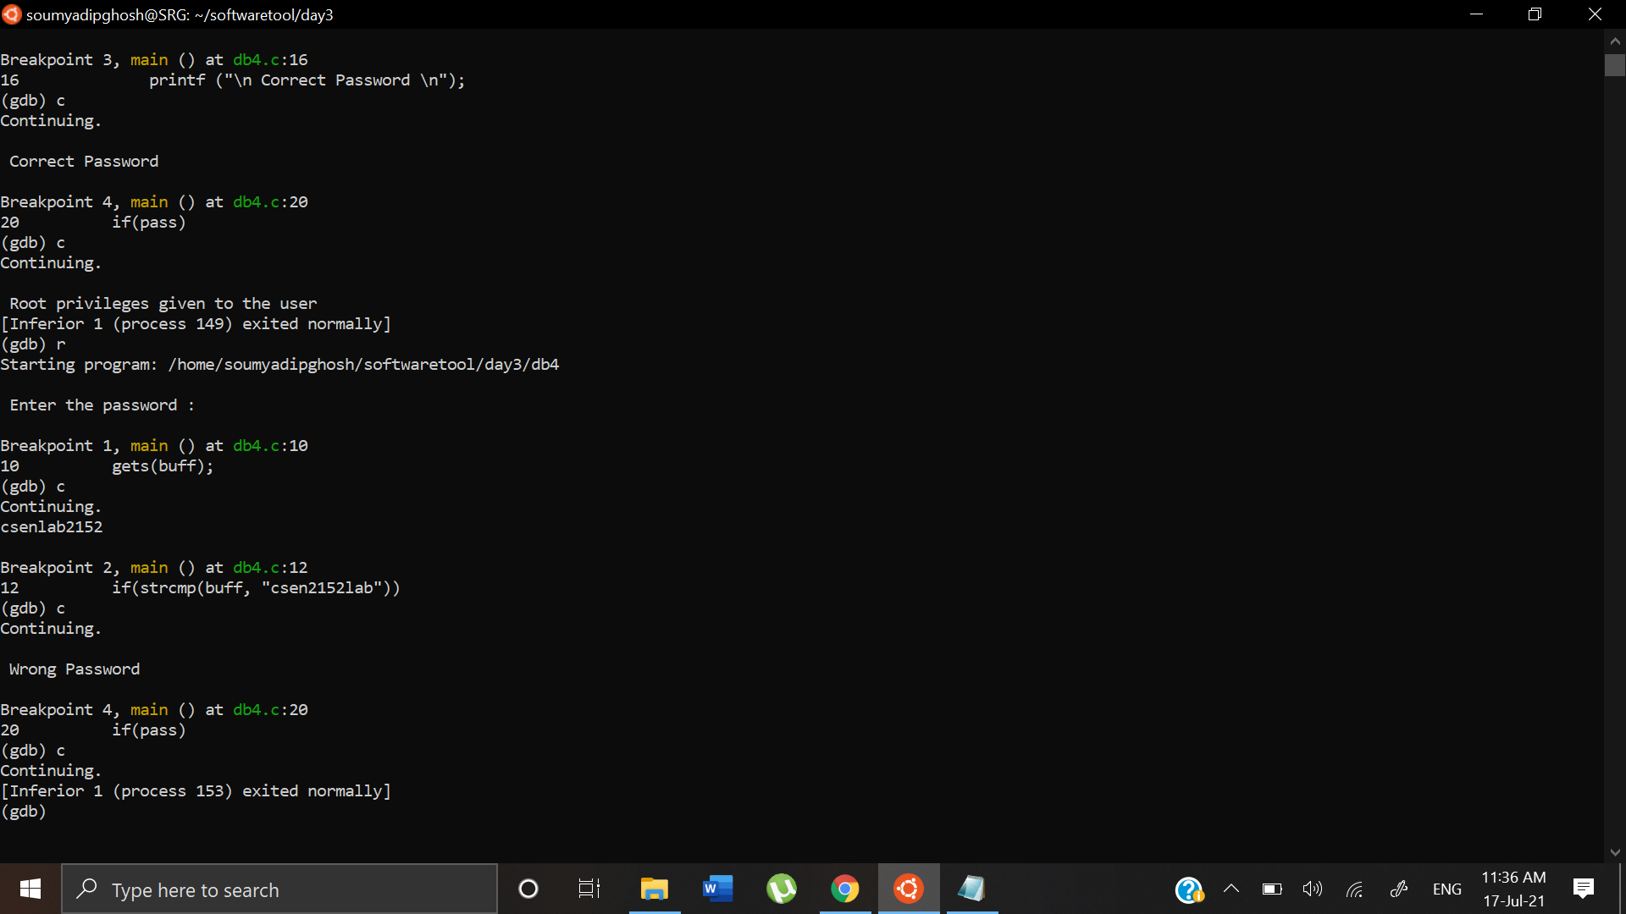

Here we can see that the program executes correctly again printing out Wrong Password and not granting root privileges to the user.

Case 3:

We input a wrong password that is more than 15 characters long

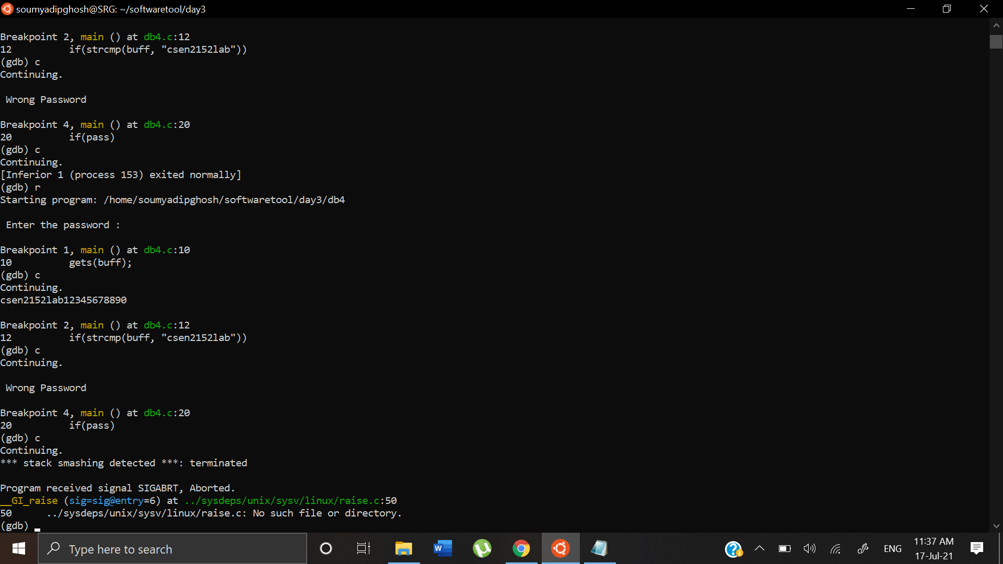

It outputs Wrong Password and the program is terminated with the error code SIGABRT. This error is occurring due to the fact that we input a password that is more than 15 characters long. The string buff is 15 characters long and since we are trying to write beyond memory bounds, this error is occurring.

DB 10:

We assign breakpoints to the following:

* main function
* Assigning \*p=25
* X=\*p

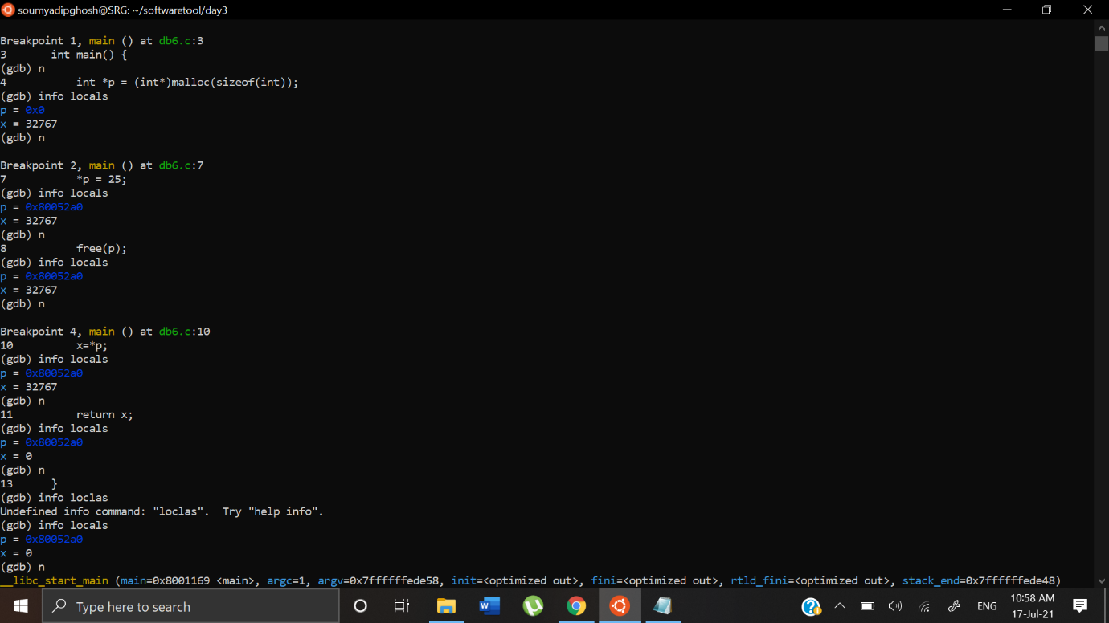

Here we are getting value of x as zero because pointer \*p has been freed and is no longer holding the value of 25

DB11:

We assign breakpoints to the following lines:

* main
* printf line

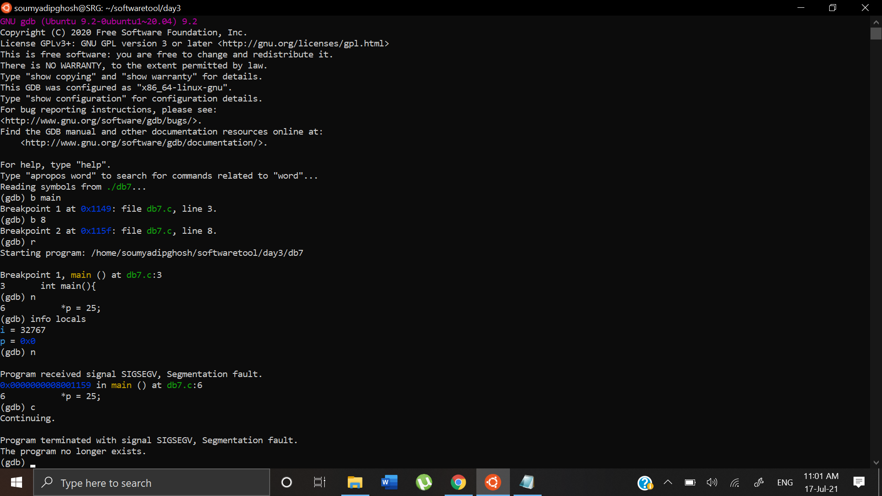

The program is getting terminated at line 6 with Segmentation Fault, SIGSEGV. We are dereferencing the pointer and making it assign a value to a random memory address. If that memory address is not empty it causes segmentation fault.

DB12:

We assign breakpoints to the following lines:

* while loop
* x=x+a[i]

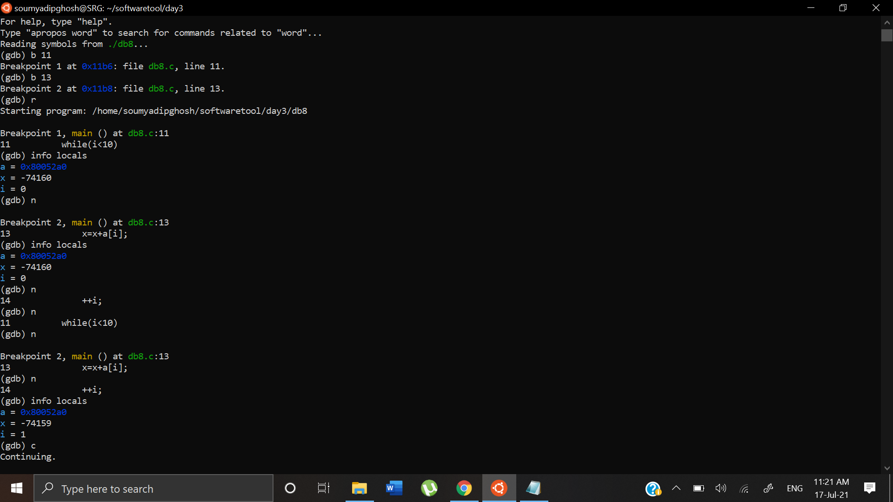

We can see x has a value of -74159 which is a garbage value. Hence after the while loop has stopped iterating, we get the following output

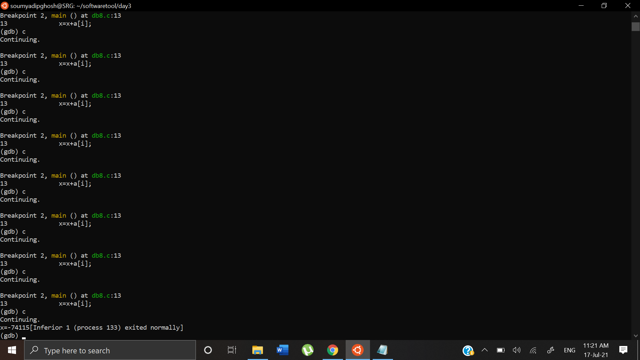

We get the value of -74115 due to garbage value stored in x.